Product Design

# Prototype 1

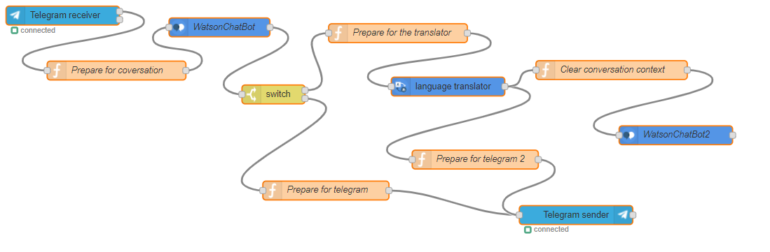For the first prototype of the project, I decided to create a simple chatbot that didn’t require much coding to work properly. I settled to do it this way so I could gain a general idea of how a chatbot is built, and what requirements does it need to be able to function and think like a human.

## Prototype 1 steps:

* First, the user will have to add the chatbot in the Telegram app, which is under the name ‘WatsonELchatbot’. After that, he will send a message to the bot via Telegram, where the chatbot is set-up. This message may contain a question or just a simple conversation starter.
* When the message is sent, it will go through my personal IBM cloud. This will then start the chatbot and the conversation.
* After the message is received in the cloud, Watson Conversation Assistant will read and understand the sentence by using IBM’s language AI.
* The switch statement in the flowchart divides the conversation in two, depending on what the user asks for in the message:
* If the user asked for the translator, then the program will chose the translator route. This way the IBM Language Translator will ask for an input (sentence) to be translated and will also ask for the language to be translated to. The AI will then translate the message to the required format and display it to the user. After this process is finished the user will get two choices:

1. Stay in the translator mode and keep translating messages.
2. Clear the conversation and start from the beginning.

* The other option is to keep talking to the chatbot in a normal conversation.